**Experiment-10**

Create a simple cloud software application for online super market using any Cloud Service Provider to demonstrate SaaS with the template of customer name, address, phone, email, items, quantity etc. with the item classification form.**Implementation:**

**STEP 01:**

Open a  Zoho web application and click a Create a New application and Create a New Component And select a Component Type as Form Type.

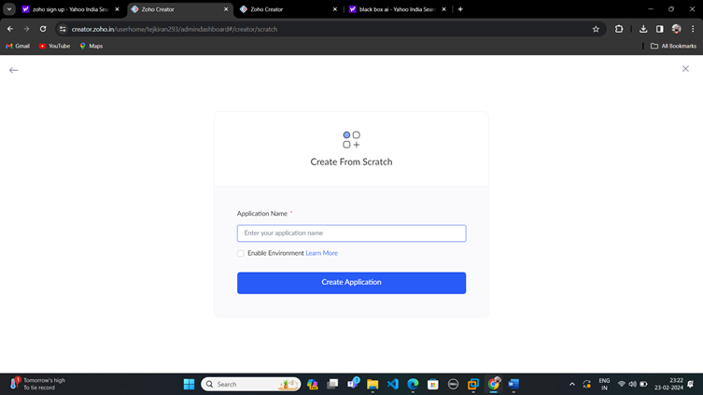

**STEP:02**

Start To a Create a Form from Scratch

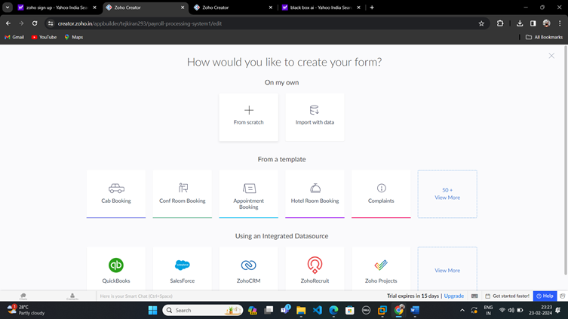

**STEP 03:**

To Give a Name For Your Form and click a Button Create From Scratch

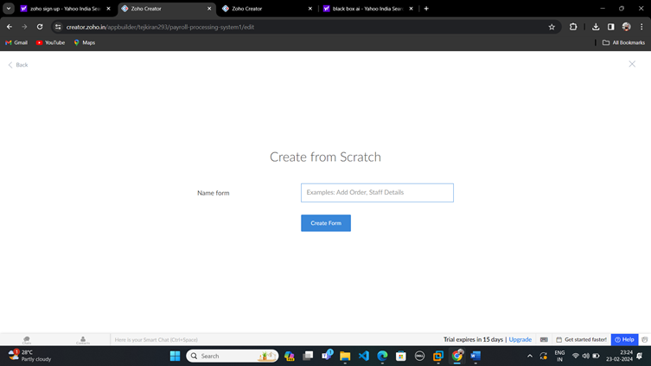

**Step-04:**

Create Log in form and edit the form

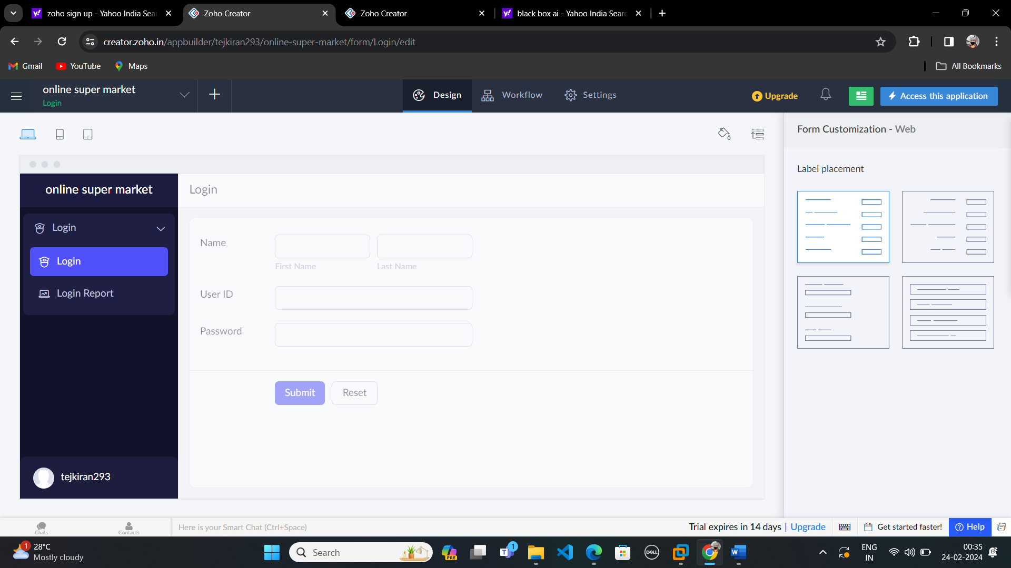

**Step-05**

After Finishing that,Create another form for your application by clicking a Add icon and Edit that form.

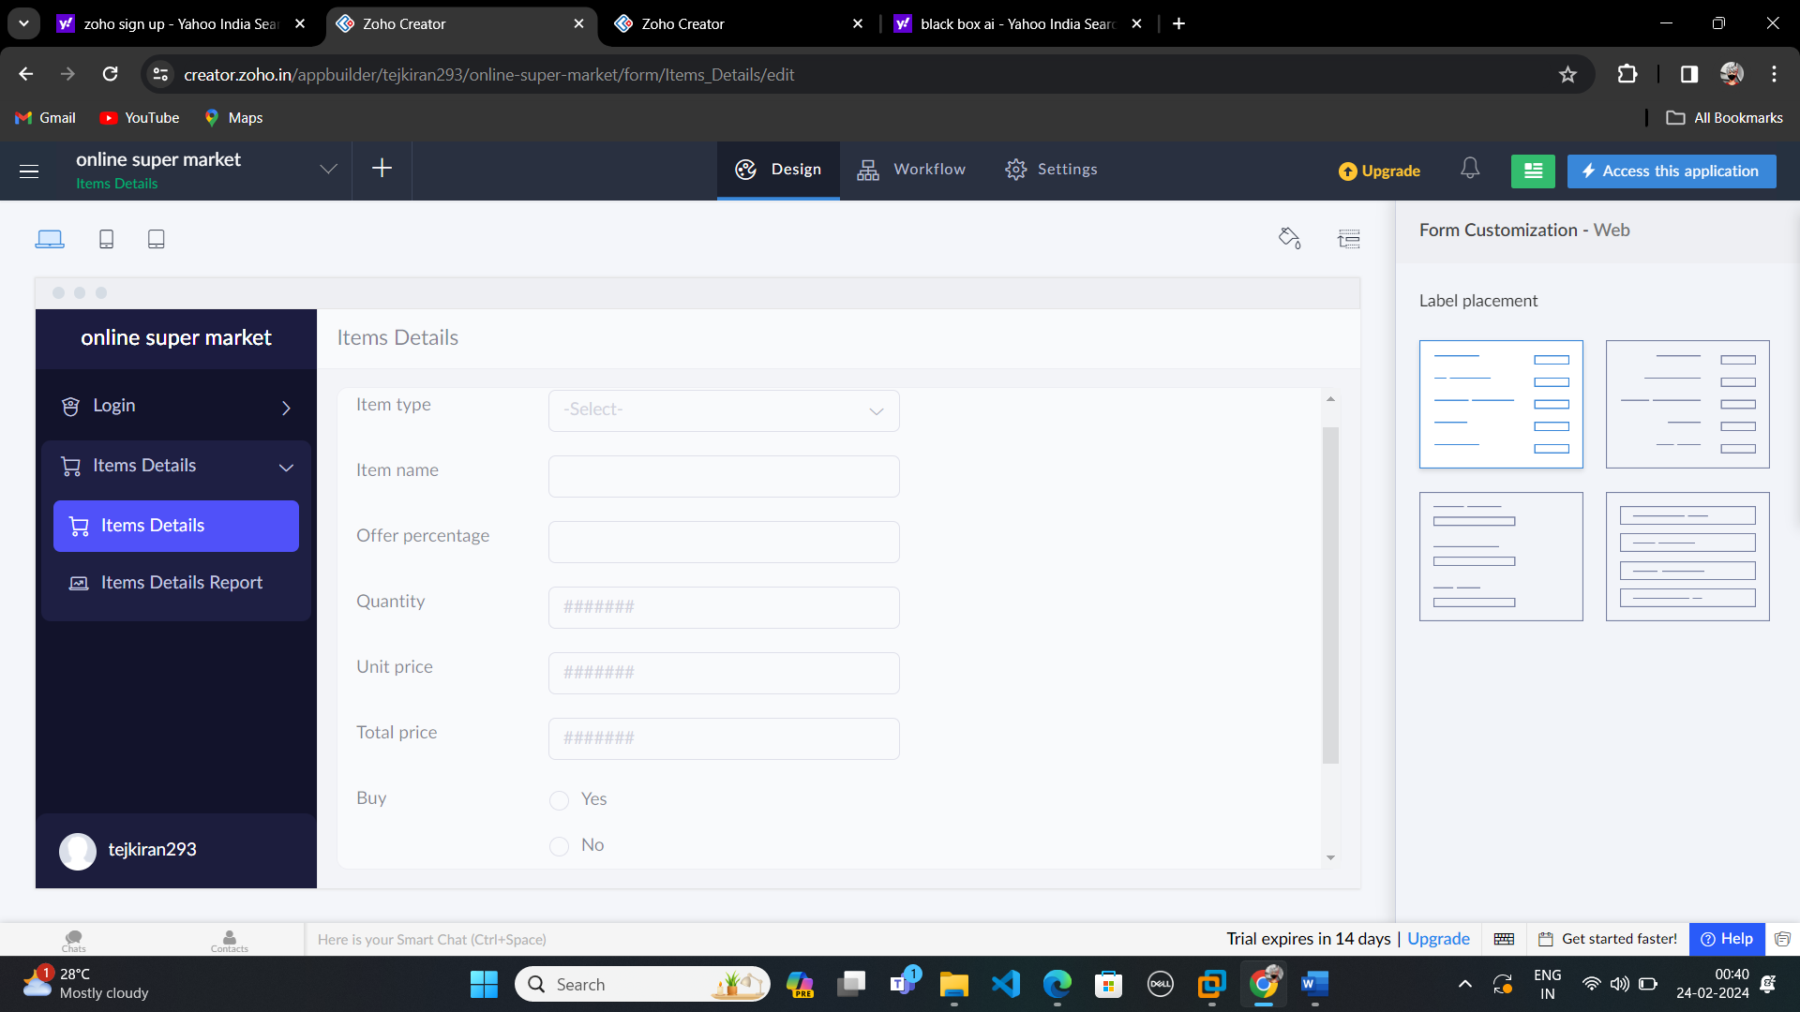

**Step-06:**

After creating that create another form and name it as Goods Details.

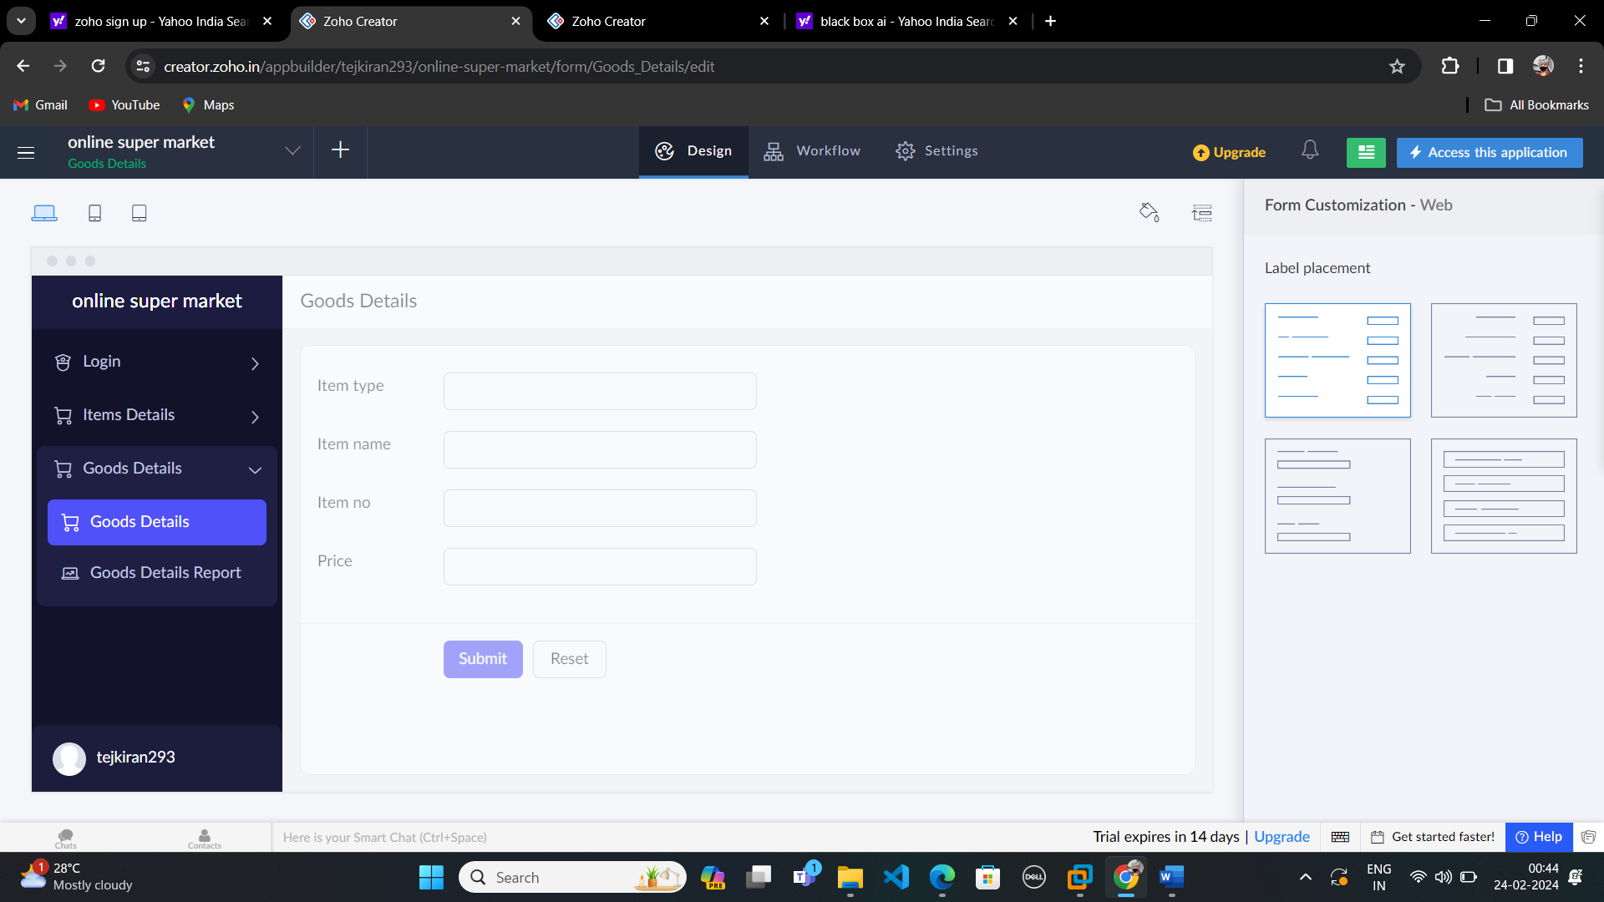

**Step-07:**

Create another form and name it as Logout

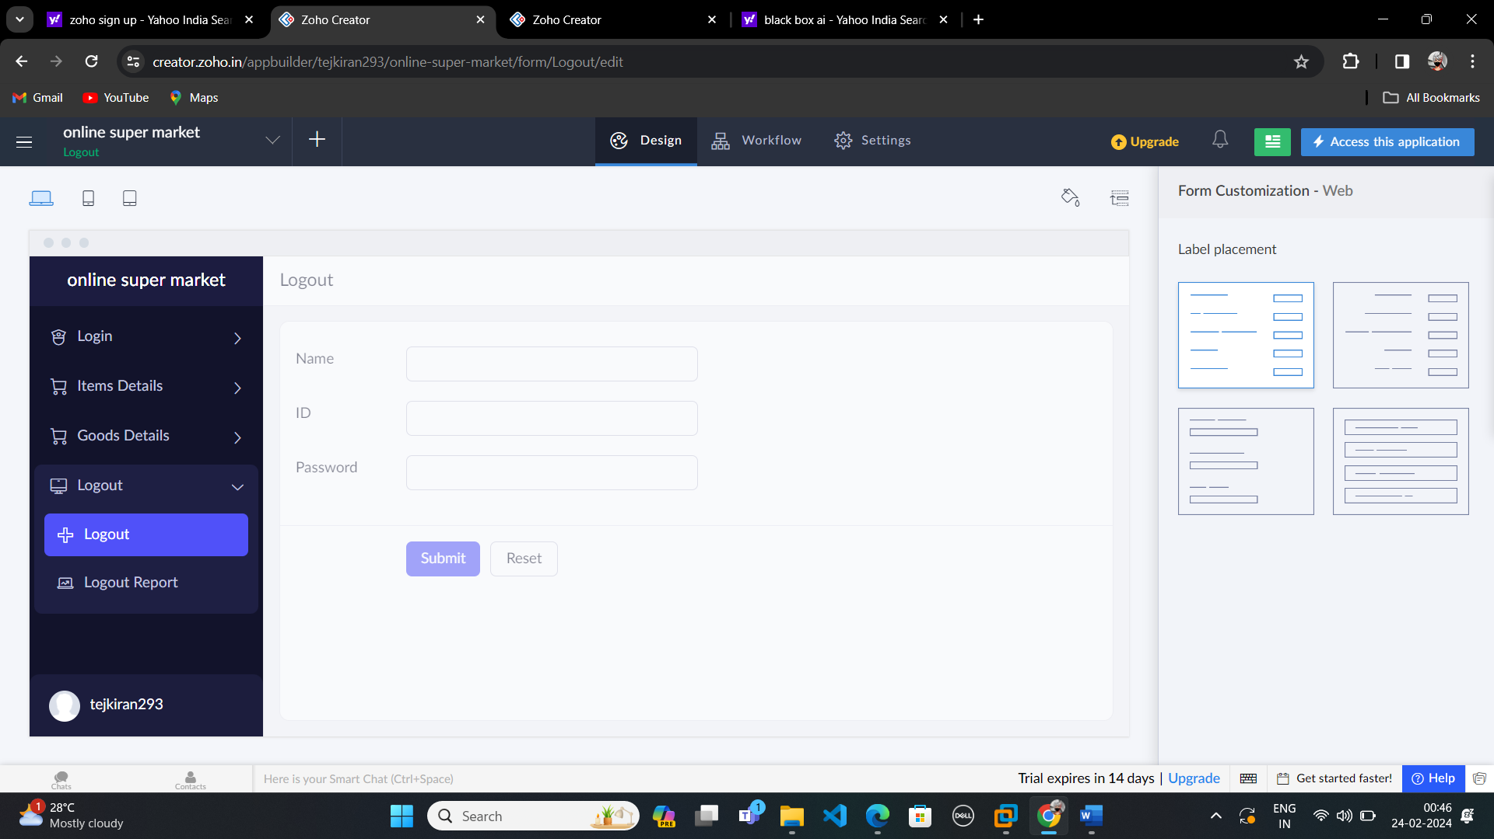

**Step-08:**

After creating report form tap Access this Application.

